Student Handbook
Docker Training
Day 3 · Session 1
Docker Compose fundamentals

Learning objectives

By the end of this session you will be able to:
- Explain the structure of a docker-compose.yml file and map its keys to docker run flags
- Write a Compose file with multiple services, a shared network, and a named volume
- Add a healthcheck to a service and use condition: service_healthy in depends_on
- Use a .env file for configuration and reference variables with ${VARIABLE} syntax
- Use profiles to define optional services that only start on demand
- Use docker compose config to validate and preview the resolved file
- Use the core Compose workflow: up, down, logs, exec, run, ps, restart
- Understand the difference between docker compose down and docker compose down -v
- Create a docker-compose.override.yml for environment-specific configuration

Compose vs manual docker run

Everything you did manually in Day 1 Session 3 is replaced by a single command. Here is the comparison:

Manual (Day 1 approach) | Compose (Day 2 approach)
docker network create appnet  docker volume create pgdata  docker run -d --name db --network appnet -e POSTGRES_PASSWORD=... -v pgdata:/var/lib/postgresql/data postgres:16  docker run -d --name api --network appnet -p 8080:8080 -e ConnectionStrings__... weatherapi:1.0  docker run -d --name ui --network appnet -p 4200:80 weather-ui:1.0 | docker compose up -d  That's it. One command.

Key concepts

services:  Root section. Each named block is one container. Keys map 1-to-1 with docker run flags. | networks:  Declared at root level. Compose auto-creates user-defined bridges with DNS. Services join by name.
volumes:  Declared at root level. Compose creates named volumes automatically. Mount per-service with volumes: key. | depends_on  Controls startup order. With condition: service_healthy it waits for a healthcheck to pass.
healthcheck  A command Docker polls periodically. Until it passes, dependent services with service_healthy wait. | .env file  KEY=VALUE pairs auto-loaded by Compose. Reference as ${KEY} anywhere in the compose file.
profiles:  Tag services with profiles: [name]. Only started when --profile name is passed to docker compose up. | env_file:  Load env vars from a file into a specific service container. Different from the root .env file.

Compose file anatomy — annotated

Read through this complete docker-compose.yml carefully. Every line is explained in a comment above it.

# docker-compose.yml
# Declares all services, networks and volumes for this project.
# Compose reads this file when you run docker compose up.

services:

# ── PostgreSQL ─────────────────────────────────────────────
db: # Service name = DNS hostname on the network
image: postgres:16 # Use this image (no build needed)
restart: unless-stopped # Auto-restart on crash; stop on docker compose stop
environment:
POSTGRES_USER: ${DB_USER} # ${} reads from .env file or shell
POSTGRES_PASSWORD: ${DB_PASS} # Never hardcode passwords here
POSTGRES_DB: ${DB_NAME} # Creates this database on first start
volumes:
- pgdata:/var/lib/postgresql/data # Named volume — data survives docker compose down
networks:
- appnet # 'db' is resolvable from any service on appnet
healthcheck:
test: ["CMD", "pg_isready", "-U", "${DB_USER}"] # Command that returns 0 when ready
interval: 5s # Check every 5 seconds
timeout: 5s # Fail if no response within 5s
retries: 5 # Mark unhealthy after 5 consecutive failures
start_period: 10s # Grace period on first start (failures don't count)

# ── pgAdmin (optional tool — only with --profile tools) ─────
pgadmin:
image: dpage/pgadmin4:latest
depends_on:
db:
condition: service_healthy # Wait for db healthcheck to pass before starting
environment:
PGADMIN_DEFAULT_EMAIL: ${PGADMIN_EMAIL}
PGADMIN_DEFAULT_PASSWORD: ${PGADMIN_PASS}
ports:
- "${PGADMIN_PORT:-5050}:80" # :-5050 = default value if PGADMIN_PORT not set
networks:
- appnet
profiles:
- tools # Only starts when: docker compose --profile tools up

# ── Top-level volume declarations ────────────────────────────
volumes:
pgdata: # Compose creates this — leave body empty for defaults

# ── Top-level network declarations ───────────────────────────
networks:
appnet: # User-defined bridge with embedded DNS

Hands-on lab steps

1 | Clean up the Day 1 environment  Start fresh before Compose takes over network and volume management

Remove Day 1 containers and manually created networks
# Stop and remove Day 1 containers (errors ignored if already gone)
docker rm -f db api ui ui-dev 2>/dev/null || true

# Remove the manually created network from Day 1
docker network rm appnet 2>/dev/null || true

# Verify only default networks remain
docker network ls
docker ps -a
Expected output:
NETWORK ID NAME DRIVER SCOPE
... bridge bridge local
... host host local
... none null local

CONTAINER ID IMAGE COMMAND CREATED STATUS PORTS NAMES
# (empty — no containers running)
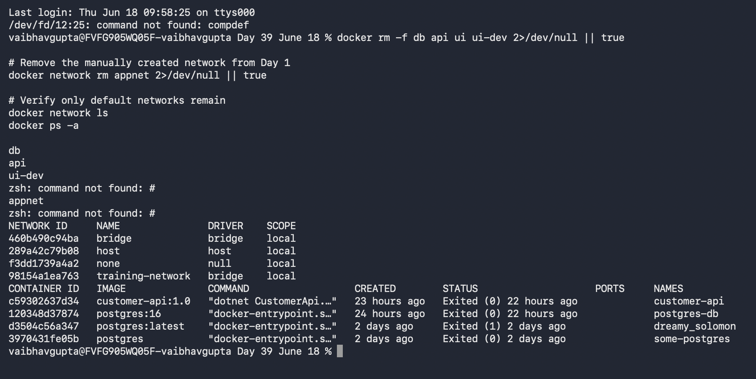
💡 Why clean up first
Compose will create its own prefixed network (compose-lab_appnet) and volume (compose-lab_pgdata). If old resources with the same name exist from Day 1, Compose may reuse them or fail with a conflict. Starting clean avoids confusion.

2 | Create project folder and .env file  Configuration via .env — never hardcode secrets in the compose file

Create the project structure
mkdir compose-lab && cd compose-lab
touch .env
touch docker-compose.yml
ls -la
Expected output:
-rw-r--r-- 1 user user 0 Jun 17 09:10 .env
-rw-r--r-- 1 user user 0 Jun 17 09:10 docker-compose.yml
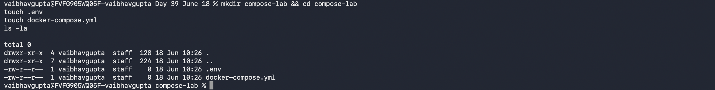
.env — paste this content (open in any text editor)
# .env — loaded automatically by docker compose
# NEVER commit this file with real credentials to git

# PostgreSQL
DB_USER=postgres
DB_PASS=Training123
DB_NAME=traindb

# pgAdmin
PGADMIN_EMAIL=admin@training.com
PGADMIN_PASS=admin123
PGADMIN_PORT=5050

Create .gitignore and .env.example
# Add .env to gitignore — real credentials stay local
echo ".env" >> .gitignore

# .env.example has keys but no values — safe to commit
cat > .env.example << 'EOF'
DB_USER=
DB_PASS=
DB_NAME=
PGADMIN_EMAIL=
PGADMIN_PASS=
PGADMIN_PORT=5050
EOF

❌ Never commit .env
The .env file must always be in .gitignore. Commit only .env.example with empty values so teammates know which variables are required. Anyone who clones the repo copies .env.example to .env and fills in their own values.

💡 Variable substitution syntax
${DB_PASS} reads the value from .env. ${PGADMIN_PORT:-5050} reads from .env but falls back to 5050 if the variable is not set — the :- syntax provides a default value.

3 | Write the Compose file — PostgreSQL with healthcheck  One service first; validate it before adding dependencies

docker-compose.yml — paste this complete content
services:

db:
image: postgres:16
restart: unless-stopped
environment:
POSTGRES_USER: ${DB_USER}
POSTGRES_PASSWORD: ${DB_PASS}
POSTGRES_DB: ${DB_NAME}
volumes:
- pgdata:/var/lib/postgresql/data
networks:
- appnet
healthcheck:
test: ["CMD", "pg_isready", "-U", "${DB_USER}"]
interval: 5s
timeout: 5s
retries: 5
start_period: 10s

volumes:
pgdata:

networks:
appnet:

Validate syntax and preview resolved variables
# Shows the fully resolved file with all ${} substitutions applied
# Any undefined variables or syntax errors appear here
docker compose config
Expected output:
name: compose-lab
services:
db:
environment:
POSTGRES_DB: traindb
POSTGRES_PASSWORD: Training123
POSTGRES_USER: postgres
healthcheck:
test:
- CMD
- pg_isready
- -U
- postgres
image: postgres:16
restart: unless-stopped
...
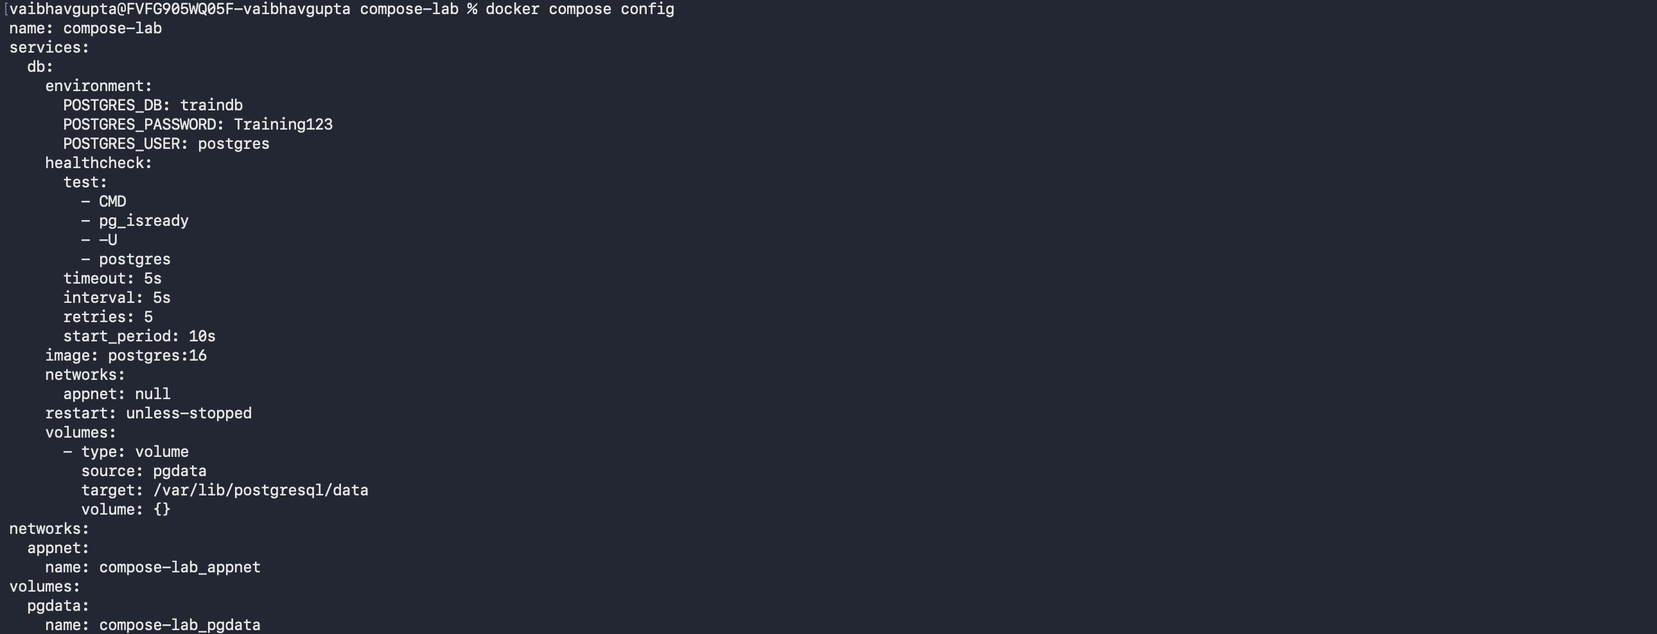
Start just the database service
docker compose up -d db
Expected output:
[+] Running 3/3
✔ Network compose-lab_appnet Created
✔ Volume "compose-lab_pgdata" Created
✔ Container compose-lab-db-1 Started
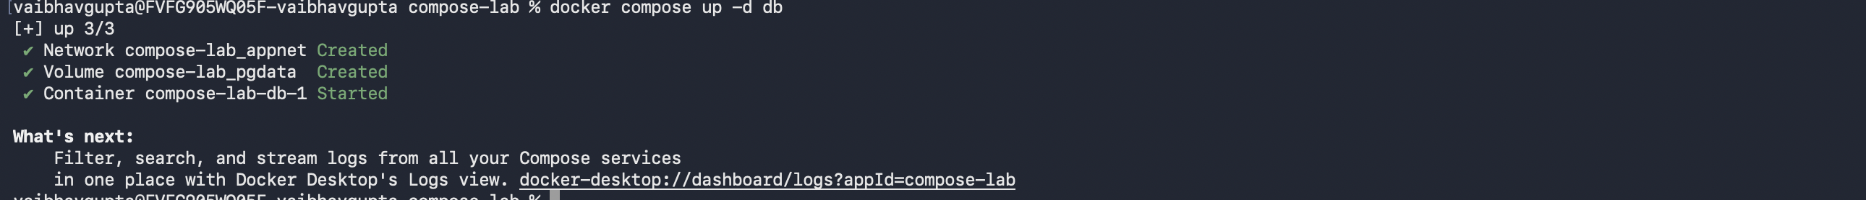
Wait for the healthcheck to pass
# Check status — wait until STATUS shows (healthy)
docker compose ps
Expected output:
NAME IMAGE STATUS
compose-lab-db-1 postgres:16 Up 12 seconds (healthy)
💡 Compose auto-prefixes resource names
Compose prefixes all resources with the project name (the folder name, compose-lab). The network becomes compose-lab_appnet and the volume becomes compose-lab_pgdata. This prevents name collisions between different Compose projects on the same machine.

💡 Healthcheck status progression
A newly started container goes through: starting (grace period) → healthy (pg_isready returns 0) or unhealthy (five consecutive failures). Dependent services with condition: service_healthy will not start until the status reaches healthy.

4 | Add pgAdmin with depends_on and profiles  Dependency ordering and optional services via profiles

Add the pgAdmin service — append inside services: in your compose file
# Append this block inside services: after the db service
pgadmin:
image: dpage/pgadmin4:latest
depends_on:
db:
condition: service_healthy
environment:
PGADMIN_DEFAULT_EMAIL: ${PGADMIN_EMAIL}
PGADMIN_DEFAULT_PASSWORD: ${PGADMIN_PASS}
ports:
- "${PGADMIN_PORT:-5050}:80"
networks:
- appnet
profiles:
- tools

Start WITHOUT the profile — pgAdmin is excluded
docker compose up -d
Expected output:
[+] Running 1/1
✔ Container compose-lab-db-1 Running

# pgAdmin is NOT started — it has a profile assigned
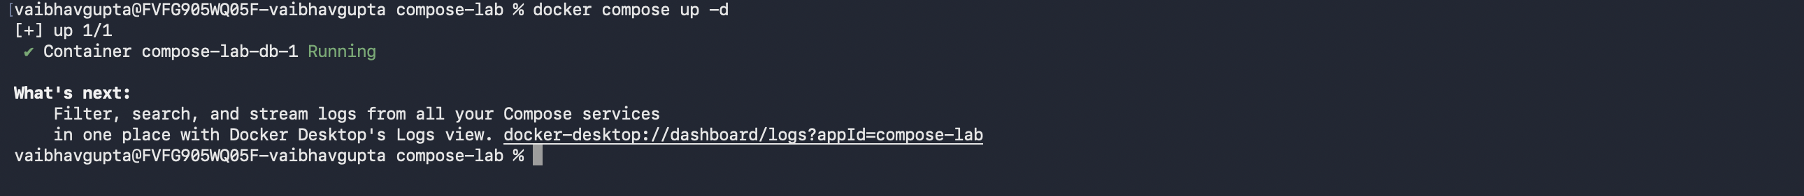
Start WITH the tools profile — pgAdmin is included
docker compose --profile tools up -d
Expected output:
[+] Running 2/2
✔ Container compose-lab-db-1 Running
✔ Container compose-lab-pgadmin-1 Started

# pgAdmin waited for db to become healthy before starting
Connect pgAdmin to the database
# Open http://localhost:5050 in your browser
# Email: admin@training.com
# Password: admin123

# In pgAdmin UI: right-click Servers > Register > Server
# Tab General: Name: traindb
# Tab Connection: Host: db <- container name, DNS resolves it
# Port: 5432
# Username: postgres
# Password: Training123

💡 condition: service_healthy vs condition: service_started
service_started (the default) only waits for the container process to start — not for the application inside to be ready. service_healthy waits for the healthcheck to pass. Always use service_healthy for databases, because postgres takes a few seconds after process start before it accepts connections.

💡 Profiles keep your compose file clean
Profiles let you define dev tools (pgAdmin, Redis Commander, MailHog) in the same file without polluting the default startup. CI/CD pipelines run docker compose up -d with no profile. Developers add --profile tools when they need the UI tools.

5 | Master the daily Compose workflow  Logs, exec, run, restart, and the down vs down -v distinction

Tail logs — all services, then a single service
# All services — Ctrl+C to stop following
docker compose logs -f

# Single service only
docker compose logs -f db

# Last 50 lines then follow
docker compose logs --tail=50 -f db
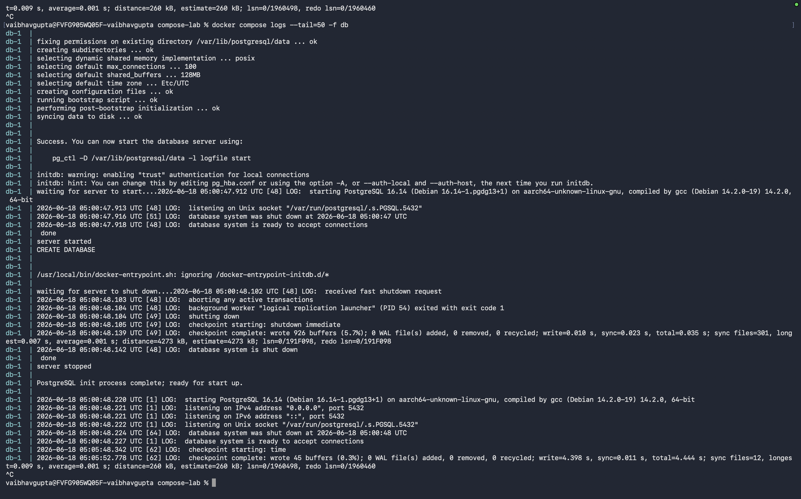
Exec into a running service container
# Interactive psql session inside the db service
docker compose exec db psql -U postgres traindb

# Non-interactive — run a command and return
docker compose exec db pg_isready -U postgres
Expected output:
/var/run/postgresql:5432 - accepting connections
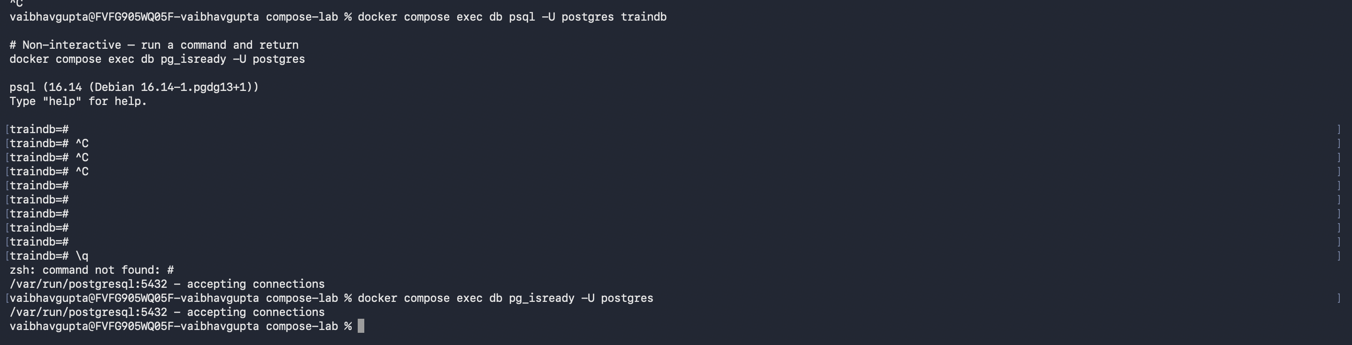
Run a one-off command in a fresh container
# docker compose run starts a NEW container (does not affect running ones)
# --rm removes the container when the command finishes
docker compose run --rm db psql -U postgres traindb -c "\\l"
Expected output:
List of databases
Name | Owner | Encoding | ...
-----------+----------+----------+---
traindb | postgres | UTF8 | ...
postgres | postgres | UTF8 | ...
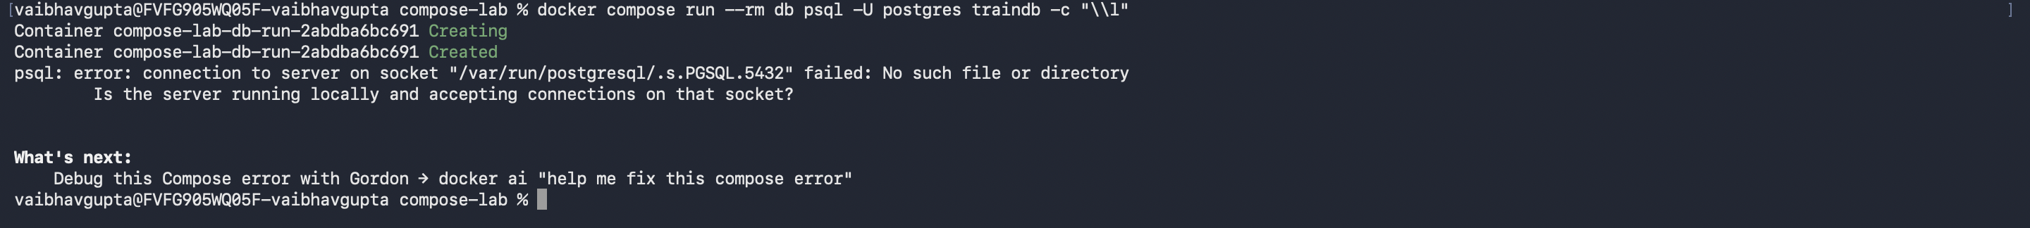
Restart a single service without touching others
docker compose restart db

Understand down vs down -v — the most important distinction
# Stop all services — containers removed, volumes and network KEPT
docker compose down
docker volume ls
# compose-lab_pgdata is still listed — data is safe

# Start again — data is still there
docker compose up -d
docker compose exec db psql -U postgres traindb -c "SELECT datname FROM pg_database;"

# Stop AND delete all named volumes — DATA IS PERMANENTLY DELETED
docker compose down -v
docker volume ls
# compose-lab_pgdata is gone
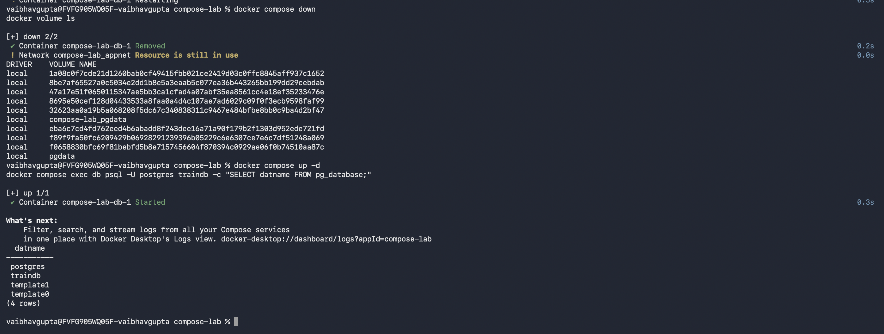
❌ docker compose down -v in production
Never run docker compose down -v on a production database. It deletes all named volumes — all your data — immediately and permanently. Reserve -v for CI/CD clean builds and local resets only. In production, remove containers with docker compose down and leave volumes intact.

6 | Use override files for dev vs prod configuration  docker-compose.override.yml is auto-merged — the standard multi-environment pattern

Compose automatically merges docker-compose.yml and docker-compose.override.yml when both exist in the same directory. The override file is additive — it extends rather than replaces.

Create docker-compose.override.yml — dev-only additions
# docker-compose.override.yml
# Auto-merged with docker-compose.yml on every docker compose up
# Contains dev-only settings — do not use in production

services:
db:
ports:
- "5432:5432" # Expose DB port so DBeaver can connect directly
# Remove this in production for security

pgadmin:
environment:
PGADMIN_CONFIG_SERVER_MODE: "False" # Skip login screen in dev

Verify Compose merges both files automatically
# docker compose config shows the MERGED result
docker compose config | grep -A 5 "ports:"
Expected output:
ports:
- mode: ingress
target: 5432
published: "5432"
protocol: tcp
# The port mapping from override.yml appears in the merged output

Explicitly select files for production (skip override)
# Use only the base file — override.yml is ignored
docker compose -f docker-compose.yml up -d

# Combine base + a separate prod file
docker compose -f docker-compose.yml -f docker-compose.prod.yml up -d

Final check — confirm services are healthy
docker compose ps
Expected output:
NAME IMAGE STATUS
compose-lab-db-1 postgres:16 Up 2 minutes (healthy)
compose-lab-pgadmin-1 dpage/pgadmin4 Up 45 seconds
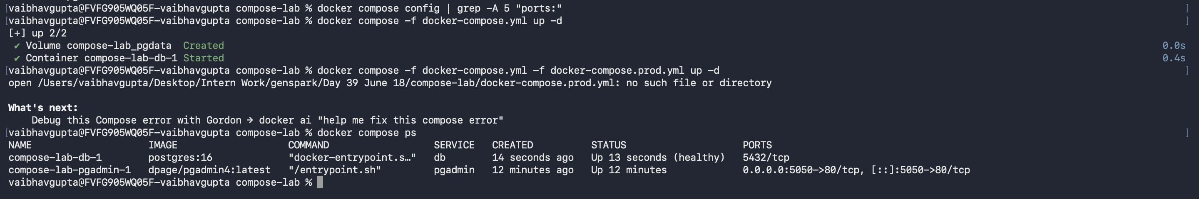
✅ Session outcome
You have a fully declarative Compose setup with: PostgreSQL with a health check, pgAdmin behind a profile, .env-based configuration, healthcheck-ordered dependencies, and an override file for dev extras. This is the foundation the full stack (Session 2) builds on.

Quick reference — Compose commands

Command | What it does
docker compose up -d | Start all services in background (creates network + volumes)
docker compose up -d --build | Rebuild images then start
docker compose up -d db api | Start specific services only
docker compose --profile tools up -d | Start default services + those tagged with tools profile
docker compose down | Stop and remove containers (volumes and network kept)
docker compose down -v | Stop, remove containers AND delete named volumes
docker compose down --rmi all | Stop, remove containers and all images
docker compose ps | List service containers and their status
docker compose logs -f | Tail logs for all services
docker compose logs -f api | Tail logs for one service
docker compose exec db bash | Open shell in a running service container
docker compose run --rm db cmd | Run one-off command in a new container, then remove it
docker compose build | Build all images without starting
docker compose build api | Build a single service image
docker compose config | Show merged, resolved compose file (validates syntax + variables)
docker compose restart api | Restart a single service
docker compose pull | Pull latest images for all services
docker compose -f base.yml up -d | Use a specific compose file, skipping override.yml

Compose file key reference

Key | Purpose and notes
image: | Docker image to use. Cannot be used with build: in the same service.
build: | Build context (path to Dockerfile). Used instead of image: for custom images.
container_name: | Override the auto-generated container name. Loses auto-scaling.
restart: | unless-stopped: restart on crash, stop on compose stop. always: restart always.
environment: | Key-value env vars. Use ${VAR} to read from .env file.
env_file: | Load env vars from a file into the container. Separate from root .env.
ports: | HOST:CONTAINER port mapping. Quoted strings avoid YAML parsing issues.
volumes: | Named volumes (name:/path) or bind mounts (./host:/container).
networks: | Networks this service joins. Service name is DNS hostname on each network.
depends_on: | Start order. Add condition: service_healthy to wait for healthcheck.
healthcheck: | test, interval, timeout, retries, start_period. Sets container health status.
profiles: | List of profile names. Service only starts when --profile name is passed.
command: | Override the default CMD from the image.
entrypoint: | Override the default ENTRYPOINT from the image.
working_dir: | Override WORKDIR from the image.
user: | Override USER from the image.

Common mistakes to avoid

❌ Mistake 1 — Using depends_on without a healthcheck condition
depends_on: db by itself only waits for the db container process to start — not for PostgreSQL to be ready to accept connections. The API will start and immediately fail to connect. Always pair depends_on with condition: service_healthy and add a healthcheck to the dependency.

❌ Mistake 2 — Hardcoding passwords in the compose file
Writing POSTGRES_PASSWORD: Training123 directly in docker-compose.yml means your password is committed to git. Always use ${DB_PASS} and store the actual value in .env. The .env file must be in .gitignore.

❌ Mistake 3 — Running docker compose down -v to 'clean up'
docker compose down -v deletes all named volumes, which means all database data. Use plain docker compose down to stop services while keeping data. Only use -v when you genuinely want to wipe the database (CI/CD clean builds, or resetting a dev environment).

❌ Mistake 4 — Forgetting to declare volumes and networks at the top level
A volume or network used inside a service must also be declared at the root level (volumes: pgdata: and networks: appnet:). If you only declare them inside a service, Compose raises a validation error. Leave the body empty for default settings.

❌ Mistake 5 — YAML indentation errors
YAML is whitespace-sensitive. Two spaces per indent level — never tabs. A misaligned key silently becomes a string value or raises a parse error. Run docker compose config after every edit to catch issues before running up.

Coming up — Session 2: Full stack with Compose

In Session 2 you will add the .NET API and Angular UI to the Compose file so the entire application starts with a single command.

- Add the api service using build: to compile from the Dockerfile
- Add the ui service and configure CORS between Angular and the .NET API
- Wire all three services on appnet so the API connects to PostgreSQL by service name
- Add a docker-compose.override.yml for Angular hot-reload with bind mounts
- Perform a hot-swap: rebuild and replace a single service without stopping the others

📋 Keep your compose-lab folder
The docker-compose.yml and .env you created today will be extended in Session 2. Leave the db container running — the next session builds directly on top of this setup.

